AUTONOMOUS BATTLE DAMAGE ASSESSMENT

PLAN
(v1.0-Final)

DOCUMENT HISTORY

DATE | STATUS | VER | AUTHOR | NOTES
20260121 | Draft | 0.1 | Cory Wingate | Create initial draft
20260128 | Draft | 0.2 | Cory Wingate | Added Tables
20260205 | Draft | 0.3 | Cory Wingate | Added Diagrams
20260207 | Draft | 0.4 | Cory Wingate | Added Paragraph Numbering
20260208 | Final | 1.0 | Cory Wingate | Formatting changes
1.0 INTRODUCTION

Battle Damage Assessment (BDA) is an essential part of military operations, helping commanders assess the physical and functional impacts of military actions. Traditional BDA methods are often manual, slow, and depend on human interpretation of imagery, leading to inconsistencies and delays in decision-making. Recent progress in Vision-Language Models (VLMs) presents an opportunity to automate parts of this process by merging visual perception with natural-language reasoning.

This project is a research-focused effort to evaluate the feasibility and performance of open-source VLM-based pipelines for generating structured BDA outputs. The project progresses through different phases from 12JAN26 to 11MAY26, covering requirements and design, data engineering and modeling, deployment and integration, and finally, evaluation, redeployment, documentation, and results presentation. The goal is not to deliver a fully fielded military system but to inform and guide future research and development efforts on integrating VLMs into BDA processes.

2.0 PROJECT PLAN TASK DESCRIPTION

Task 1: Requirements Gathering and Design

Start Date: 19JAN26

End Date: 08FEB26

Resources: Project team members; course-provided templates and guidelines; GitHub; Slack; Google Meet; Miro board.

This task involves defining the problem statement, research objectives, success criteria, and overall project direction. Implementation depends on close coordination among project team members and collaboration with project mentors and personnel at the Army Research Laboratory (ARL). Course-provided templates, relevant academic literature, and technical references guide the development of the Vision, Requirements, Design, and Plan documents.
During this phase, assumptions, risks, and constraints are identified through structured team discussions, mentor feedback, and literature review. High-level system and evaluation architectures are documented using diagramming tools on a shared Miro board. As part of establishing the project foundation, a GitHub repository is created to support version control, collaboration, and task tracking via GitHub Projects (see Fig A1.1). The project team also collaboratively defines and agrees upon a standardized BDA report format to ensure consistency across dataset preparation, model development, and evaluation activities.

Task 2: Data Engineering and Modeling

Start Date: 09FEB26

End Date: 15MAR26

Resources: Local workstations; Google Cloud Drive; open-source datasets.

This task begins by identifying and analyzing publicly available datasets that showcase various military assets relevant to our project’s model design, BDA evaluation criteria, and workflow. Our initial data storage plan involves using a single shared Google Drive folder for all collected images, with a separate folder containing a text file to record the group’s consensus BDA assessment of the images (see Fig. A2.1) [1]. Although we haven’t yet established a formal data schema or data dictionary, we will reevaluate the need for more structured data management if our pipeline grows in scale or complexity.

This task also outlines model design and evaluation strategies. The baseline approach combines open-source VLMs with open-source object detection models, with outputs evaluated by a Large Language Model (LLM) against human-authored reference responses. Phased model setups are described, including a VLM-only baseline and an integrated object-detection-and-VLM pipeline. These phased setups establish a structured foundation for later deployment and formal evaluation.

Task 3: Deployment and Integration

Start Date: 16MAR26

End Date: 12APR26

Resources: Container runtime; evaluation scripts; open-source datasets; instruction-tuned LLMs; local workstations; limited cloud-based virtual machines; open-source libraries.

This task focuses on setting up, testing, and validating the BDA pipeline in preparation for formal evaluation. Development starts with a VLM-only configuration to establish a functional baseline, verify proper end-to-end reasoning, and ensure the creation of a structured output. Prompt templates for both the VLM and LLM are created and continuously refined to support consistent downstream evaluation. After validating the VLM-only pipeline, the object detection component is added and tested to confirm correct interaction between detection outputs and VLM reasoning. Finally, end-to-end integration is verified across data ingestion, object detection, VLM reasoning, and structured output creation to ensure the pipeline functions as a unified system (see Fig. A3.1).

After staged testing, both model pipeline configurations will be containerized to verify Dockerfile image creation and to evaluate image properties for potential deployment on edge robotic environments. This also prepares the images for the redeployment phase in Task 4, where the best-performing model pipeline suitable for edge deployments will be selected for operational validation on an ARL robotic platform. Additionally, operational testing of these container images will be conducted on an Azure Virtual Machine (VM) configured to closely match the runtime characteristics of the ARL robotic platform. Meanwhile, DevOps workflows are established and validated to ensure consistent execution, version control, and experiment tracking. Functional testing and integration checks are performed throughout this phase to confirm system readiness before formal evaluation.

Task 4: Evaluation and Redeployment

Start Date: 13APR26

End Date: 11MAY26

Resources: Evaluation tooling; reporting/presentation software; data visualization tools; instruction-tuned LLMs for automated judging; human-authored reference BDA responses; robotic platform for edge testing.

This task focuses on the formal evaluation of deployed BDA pipelines using a structured LLM-as-a-Evaluator (LLMaaE) methodology aligned with human reference responses. For each evaluated image, the pipeline generates a structured JSON BDA output (see Fig. A4.1) [2] from the VLM, which is paired with a corresponding human-authored BDA response created during earlier dataset preparation. Both outputs are provided as inputs to an LLM acting as an automated evaluator.

The LLMaaE compares each model-generated response to the corresponding human reference, focusing on relevance to the scene and correctness of the evaluated damage. For each comparison, the LLM assigns a quantitative pass/fail score, with results documented in a structured format and compiled utilizing an automated script (see Fig. A5.1). This setup enables aggregation across images and different model configurations. The evaluation process is applied consistently across all tested settings, including the VLM-only and VLM-integrated object detection pipelines, allowing for systematic performance comparisons.
After collecting the evaluation results, they are analyzed to identify strengths and weaknesses across different configurations. Based on these insights, the top-performing model pipeline most suitable for edge deployments is selected, packaged in a container, and tested and validated on an ARL robotic platform. This process also involves preparing final reports, slide decks, poster materials, and supporting documentation to clearly communicate the evaluation methodology, results, and conclusions.

3.0 PROJECT TIMELINE AND MILESTONES

Table 1 Project Timeline and Milestones
Milestone | Description | Date
M1 | Requirements gathering, system design, standardized BDA format definition, and project planning completed | 08FEB26
M2 | Dataset acquisition complete, directory-based data storage and labeling structure implemented, and model design finalized | 15MAR26
M3 | End-to-end validation of all BDA pipeline configurations completed, and Dockerfile configurations tested and verified | 12APR26
M4 | Evaluation completed, best-performing BDA pipeline selected and deployed to the ARL robotic platform, and deliverables prepared | 05MAY26
M5 | Final presentation delivered, project artifacts submitted, and project close-out completed | 11MAY26

Table 2 Expanded Milestone Breakdown
ID | Sub-Milestone | Description | Start Date | End Date | Task Owner
M1.1 | Problem Definition | Finalize BDA problem statement, research objectives, success criteria, and evaluation goals | 19JAN26 | 26JAN26 | Team Members
M1.2 | System and Evaluation Design | Define system architecture, evaluation methodology, and standardized BDA report format | 27JAN26 | 02FEB26 | Team Members
M1.3 | Planning Documentation | Complete Vision, Requirements, Design, and Plan documents | 03FEB26 | 08FEB26 | Team Members
M2.1 | Dataset Identification | Identify and assess publicly available datasets relevant to BDA and object detection | 09FEB26 | 16FEB26 | Nick
M2.2 | Data Organization and Labeling | Create an image storage directory and a text file for evaluation results, and completion of group BDA assessments | 17FEB26 | 24FEB26 | Nick
M2.3 | Pipeline Configuration Development | Develop VLM-only and integrated object detection plus VLM pipeline configurations | 25FEB26 | 05MAR26 | Carlos, Cory, Iggy
M2.4 | Model Design Finalization | Finalize model design choices and evaluation setup across all pipeline configurations | 06MAR26 | 15MAR26 | Iggy
M3.1 | Prompt Template Development | Design, test, and refine prompt templates for VLM and LLM-based BDA generation and judgement | 16MAR26 | 20MAR26 | William
M3.2 | End-to-End Pipeline Validation | Validate end-to-end functionality of all BDA pipeline configurations | 21MAR26 | 30MAR26 | Team Members
M3.3 | Container Configuration Testing | Develop, test, and verify Dockerfile and container runtime configurations | 31MAR26 | 05APR26 | Cory, Carlos
M3.4 | Deployment Readiness Validation | Validate containerized pipeline execution in a simulated edge environment | 06APR26 | 12APR26 | Cory, Carlos
M4.1 | Evaluation Execution | Execute LLM evaluations across all pipeline configurations | 13APR26 | 25APR26 | Team Members
M4.2 | Results Analysis and Selection | Analyze evaluation results and select the best-performing BDA pipeline configuration | 26APR26 | 02MAY26 | Team Members
M4.3 | Robotic Platform Deployment | Deploy and validate the selected containerized pipeline on the ARL robotic platform | 03MAY26 | 05MAY26 | ARL Mentors
M5.1 | Final Deliverables and Close-Out | Complete final presentation, submit project artifacts, and conduct project close-out | 06MAY26 | 11MAY26 | Team Members

4.0 TERMINOLOGY, DEFINITIONS, ACRONYMS, AND ABBREVIATIONS

Battle Damage Assessment (BDA): The process of determining the physical and functional damage to targets following military action.

Vision-Language Model (VLM): A machine learning model that combines visual perception with natural language understanding to reason over image-based inputs.

Large Language Model (LLM): A language model trained on large-scale text corpora to perform reasoning, summarization, and text generation tasks.

LLM-as-a-Evaluator (LLMaaE): An evaluation methodology in which a Large Language Model is used to assess the quality, relevance, or correctness of generated outputs relative to reference responses.

Edge Environment: A compute environment characterized by constrained resources, limited memory and processing power, and the absence of persistent network connectivity.

Object Detection: A computer vision task focused on identifying and localizing objects of interest within an image.

Containerization: The practice of packaging software, dependencies, and configurations into a portable container to enable consistent execution across environments.

Docker: A container runtime platform used to build, package, and run containerized applications.

Prompt Tuning: A technique for adapting language or vision-language models by optimizing prompts rather than modifying model weights.

DevOps: A set of practices that combine software development and operations to enable automation, version control, testing, and repeatable deployments.

Robotic Platform: A physical robotic system capable of executing onboard compute workloads and operating in an edge environment.

JavaScript Object Notation (JSON): A machine-readable format used in this project to represent standardized, pipeline-generated BDA results.

5.0 REFLECTION AND LESSONS LEARNED

Creating this Plan Document revealed the considerable time and iterations needed to develop a practical technical plan, especially with ongoing design decisions and shifts in project direction. A key lesson learned was the importance of breaking down high-level goals into specific, actionable tasks and assigning clear ownership to ensure accountability and progress. The planning process also highlighted the need to focus on tasks that directly supported the project’s evaluation goals, avoiding work that did not meaningfully contribute to the project objectives. Lastly, effectively distributing tasks across a full academic semester required careful scheduling and ongoing reassessment to ensure important milestones would be met within the available time and resource constraints.

6.0 REFERENCES

[1] Joint Staff, Methodology for Combat Assessment, CJCSI 3162.02A, Washington, DC, USA, Jul. 16, 2021. Accessed: Jan. 25, 2026. [Online]. Available: https://www.jcs.mil/Portals/36/Documents/Library/Instructions/CJCSI%203162.02A.pdf

[2] T. Bray, “RFC 8259: The JavaScript Object Notation (JSON) data interchange format,” IETF Datatracker, https://datatracker.ietf.org/doc/html/rfc8259 (accessed Jan. 30, 2026).

7.0 APPENDIX A

Appendix A1. Human-Authored Reference BDA Responses
Figure A1.1
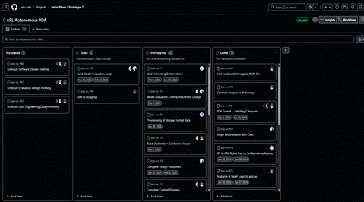

GitHub Repo: https://github.com/cmu-bda/bda-svc

Appendix A2. Human-Authored Reference BDA Responses
Figure A2.1
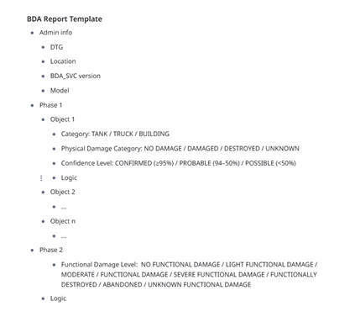
Appendix A3. System Architecture Diagrams
Figure A3.1
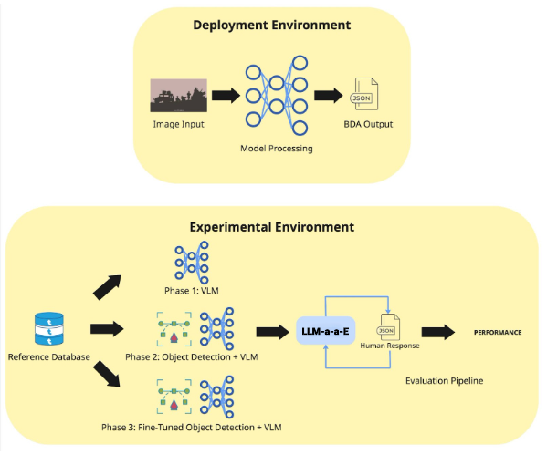

Appendix A4. Sample Structured JSON BDA Outputs
Figure A4.1
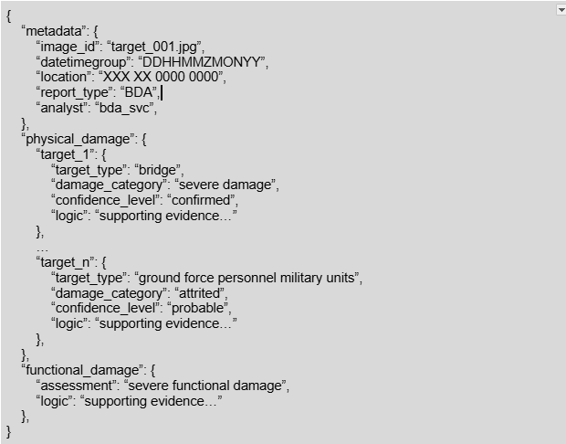

Appendix A5. Evaluation Workflow Diagrams
Figure A5.1

